|  |  |  |  |  |  |  |
| --- | --- | --- | --- | --- | --- | --- |
|  |  |  |  |  |  |  |

**Topic**

**MEMDY**

Final Year Project Proposal

by

**Ghulam Hussain, Imran Ali, Rajesh Kumar**

**Supervisor: Khalid Hussain**

Sukkur IBA University  
Computer Science Department

(2021)

Contents

ABSTRACT 3

INTRODUCTION and BACKGROUD 4

PROBLEM IDENTIFICATION 5

Target customers: 5

LITERATURE REVIEW 6

PROJECT RATIONALE 6

PROJECT GOAL 7

Functionalities of web Application. 7

Project Category: 8

Hardware Specification: 8

PROJECT TECHINCAL APPROACH AND METHODLOGY 8

Technology: 8

PROJECT MILESTONES AND DELIVERABLES 8

Description and Deliverables 9

Gantt chart: 10

WORK DIVISION 10

COSTING. 11

REFERENCES 11

**MEMDY**

## ABSTRACT

Entertainment is necessary to keep the human mood fresh. For serenity, Memes play an important role that shares humans to humans, their ideas, value or patterns of behaviors through memes. Along with it, meme has role in such regard to helping people live joyfully (Xie el, at. 2011).. Memer's community is being rapidly expanding in this age of social media. They've become our go-to source of fun in our daily routine. Memers exhibit their creativity through memes that delight people, but it's fair to argue that they spend their time being creative, but they still do not get any reward for doing this. They put their efforts and still are unable to make money for creating joyful memes. Therefore, we propose a tool and social web app to the meme creators for two reasons, firstly, memers may produce trending, entertaining, and informative memes and secondly, they can earn money from the app. But they need to be monetized themselves. They will be paid coins as a reward and which will be converted into cash and can be withdrawn later. Lastly, this web app will be developed using React JS for the front-end, Node JS for the backend, and MongoDB for Database. This tool will be web-based, but it will also include functionality for generating and editing in a (social media) mobile app.

***Key Terms:*** *Memes, Entertainment, Social-media, React JS, Node JS, MongoDB*

## INTRODUCTION and BACKGROUD

After uprising of Digital media, Entertainment becomes necessary to keep mood fresh. Everyone is looking for to keep its mood fresh. Keeping mood fresh is a challenging thing in this time because everyone is facing some type of problem (Xie el, at. 2011). One of medium of making mood positive is using social media. This he to make their humans their mood refresh through social media, social media has become important part of our lives where everyone used to spend most of its time and try to entertain itself.

To keep people entertain on social media Memer’s play a prominent role in such regard to helping people live joyfully. Memes are created by the memers and shared on social media platforms like Facebook, Instagram and whatsApp. Memer’s spend their time put their efforts to create good memes, they spread happiness on social media. Memer’s community is not famous as youtube community. They are also not earning from social platform.

The purpose of this study is to create a platform with the name “MemDY” in which memers get all functions in a single platform such as editing tools, content related to memes and platform where memers can share their memes on the same time. Additionally, the community of memers get fame from this platform with earning as well. MemDY application will be consist on two modes web application and mobile application.

Web application consist on following features;

* Editing Tool
* Search and filters
* Library of memes
* Supporting media
* Social platform

Editing tool will be consist of typography, frames, filters and colors. In search and filters there will be different filters which will be applied on image like black and white, fresh, night, movie, food and travel once the user search the image then filters can be applied on image.

Meme library consists of trending memes of other memer’s and those meme image can be edited by the other Memer. Supporting media is also consist on images where different type of images is available and these images can be selected by the Memer. Once Meme is created then it can be publish on social platform, in social platform that meme will be added to memer’s profile and meme will be visible to the user on mobile application. In web application Memer can create meme and can share it on social platform. After publishing the image on social platform it will be visible to users on mobile application where user can like and share and comment on meme.

Application interface will be similar like Tiktok where user can scroll up and down to see different meme of different memer’s. Trending memes will be shown to the users first once the application is opened. Memer can earn through coin base system coins will be generated. The more like’s memer’s meme gets then more coins will be generated and through that coins Memer can earn money. Memer’s can also earn through promoting different brands by their memes.

Memer can get fame through follower the more follower Memer gets then more fame Memer gets. MemDY platform provides a proper platform to the memer’s where they can get fame and earn money, through MemDY memer’s can build their career.

## PROBLEM IDENTIFICATION

Problem is identified when it’s been observed that memer’s putting their efforts to create memes and share them on social platform’s like Facebook, Instagram and whatsApp. People enjoy and keeps their moods refresh through those memes, there is no any proper tool is available for memer’s where they can create meme and share on a single platform. They used to share memes on different platforms.

Becoming as memers, looks hidden talent which doesn’t have platform for getting fame and earning like others platform such as YouTube, Facebook and Twitter.

### Target customers:

There are two types of target customers.

* **Memers:** The memers will create memes.
* **Users:** The audience who will use application to see the memes for entertaining purposes.
* **Clients:**

## LITERATURE REVIEW

In the light of literature, a number of websites and application are found in which the memes can be used for entertaining purpose (Xie el, at. 2011). Along with it, this culture has also trending on marketing purpose in the business field. One of the platform in literature is memes website ([www.memes.com](http://www.memes.com)) in which memer is able to create memes and post on the same platform. Canva is also one of the platform that provides resources related to create memes only (www.canvas.coms). It is web-application that provides image editing features and video editing. Additionally, it has some other features that different from memes features such as resuming, letter, report and planning. In designing section, it is providing platform of making logo, flyers, posters, blog banner, business card and label making. Image editing is a features which is flexible to share the same edited image to the social platform by sharing option. This canvas two modes; Free & Paid; free has very specific option that affects audience to visit again and paid version is very costly that allows memers to use this paid version only for entertaining.

Above literature shows lots of gape in this field that helps research to state a problem. In memes.com website doesn’t have any earning system which attract developers to update its website accordingly. This application is exist as only website as the demand of users is android which means mobile application that is missing in this platform. In canva platform, there is no any attractive material that emphasis memers to invest their costs for creating such a meme which helps memers to get fame or any sponsorship. These platform needs to look at these gapes for making applications on the top.

## PROJECT RATIONALE

There is no any proper meme application is available for memer’s where memer’s can create memes and upload them. Memer’s used to create memes on different websites and then upload them on different social platforms like Facebook, Instagram and share them on WhatsApp. People refresh their moods through memes. Memer’s put their efforts to create memes they entertain people in resemble of that they are not getting anything no fame, no earning even they have no future. Even there is no any proper platform for memes, there is some websites like canvas and memes.com which will providing editing features. Memes.com is also providing editing features and memes can be share there, memes.com has simple interface which is not attractive it also provides less editing functionalities. MemDY application is consist on two modes web application and mobile application, in web application user can create meme and publish it which will be added to its profile. Mobile application provides similar interface like Tiktok where user can follow Memer. User can also give like, share, comment on memer’s meme, through MemDY memer’s can get fame, earn and build their future. We are selecting this project as our FYP because through this project we can to help memer’s community that they can get fame, earn and build their future.

They are putting their efforts to make people laugh on social media, people refresh their mood through memes that’s the reason we choose this project as our FYP. Through this project we will learn new technologies like how social application works. We will also go in depth in React JS, Node JS and MongoDB with that we will use the concepts of Object oriented programming, software engineering, research methodology. This project will also help us to learn many more things

## PROJECT GOAL

MemDY will provide a proper social platform to memer’s where memer’s can edit and share memes. MemDY is consist on two modes.

Web Application where memes can be created and then memes will be published that meme will be added to memer’s profile.

### Functionalities of web Application.

* Editing Tool
* Search and filters
* Library of memes
* Supporting media
* Social platform

Once meme is published then on mobile Application meme can be seen by the user and user can like, share, follow and comment on meme. MemDY provides fame, earning and a career to memer’s. There is no any platform which provides these functionalities, although there are some platforms they only just provides editing functionalities.

### Project Category:

This is web-based application and Mobile Application.

Hardware Specification: This system will be accessible on internet enabled computers and smart phones.

## PROJECT TECHINCAL APPROACH AND METHODLOGY

We will be using Waterfall Model methodology that is also known as Linear Sequential Life Cycle model. It is a structured software development methodology that follows sequential order. Development team moves to next phase only when previous phase is completed successfully. In waterfall methodology, client’s requirements are gathered at beginning and then a sequential project plan is created to implement those requirements. This development methodology is best suited to our project as we also require SRS and SDS before development phase.

### Technology:

* **Frontend:** React JS will be used for frontend.
* **Backend:** Node JS will be used for backend.
* **Database:** MongoDB will be used for Database.

**UI design**

**Typography**

**Frames**

**Images**

**Trend Memes**

**User profile**

**Publish (mobile and website)**

**Logout**

**Mobile Dashboard**

**Mobile User Profile**

**Meme Sharing**

**API Integration**

## PROJECT MILESTONES AND DELIVERABLES

• Abstract defense

• Proposal defense

• FYP Phase I (Mid Defense)

• FYP Phase II (Final Defense)

## Description and Deliverables

**Abstract defense:**

The activities to reach these milestones are brainstorming, project idea formation and abstract presentation, and deliverable are:

• Project Abstract document

**Proposal defense:**

The activities that precede this milestone are writing project proposal document and proposal defense, and deliverable are:

• Project proposal document

**FYP Phase I (Mid Defense):**

The activities up to this milestone are software requirement document and software design document development that are resulting from Analysis and design phase of project. FYP Phase I deliverables are:

• Software requirement document

• Software design document

**FYP Phase II (Final Defense):**

This phase includes implementation and testing of project where deliverables are: • Software System

• Final project report

## Gantt chart:

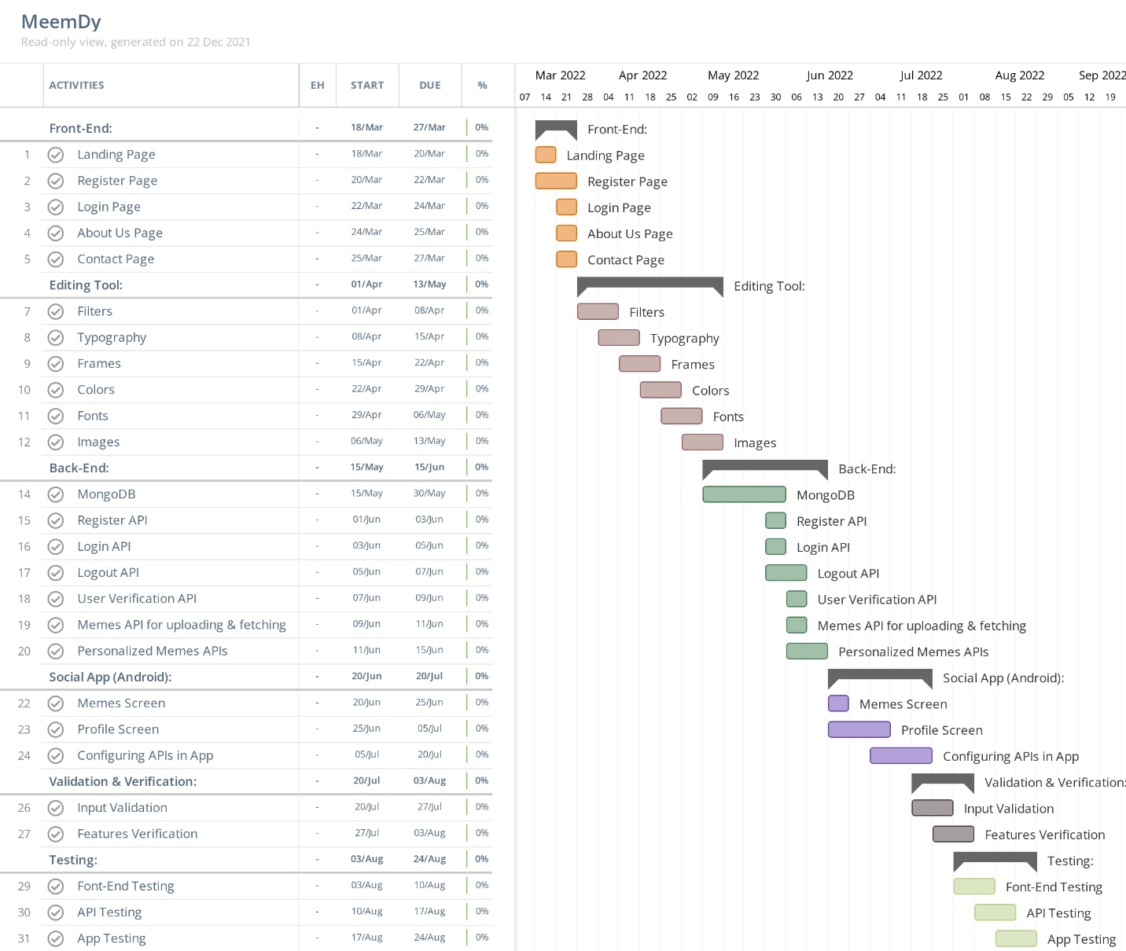

## WORK DIVISION

|  |  |
| --- | --- |
| Module Execution | Member Assignment |
| Proposal | Ghulam Hussain, Rajesh, Imran |
| SRS | Ghulam Hussain, Rajesh, Imran |
| SDS | Ghulam Hussain, Rajesh, Imran |
| **Website development** | |
| **UI design** | Ghulam Hussain, Rajesh, Imran |
| **Dragging** | Ghulam Hussain, Rajesh |
| **Images and filter** | Ghulam Hussain |
| **Frames** | Ghulam Hussain, Rajesh |
| **Colors** | Imran |
| **Trending Memes** | Ghulam Hussain, Rajesh, Imran |
| **Typography** | Rajesh, Imran |
| **Library** | Ghulam Hussain, Rajesh, Imran |
| **API Integration** | Ghulam Hussain. Rajesh, Imran |
| **Publish meme** | Ghulam Hussain |
| **Pick content from library** | Rajesh |
| **User profile** | Ghulam Hussain Rajesh |
| **Database** | |
| Database requirement | Ghulam Hussain |
| Database Analysis | Rajesh |
| Database Implementation | Imran Suhag |
| **Mobile Application** | |
| **User profile** | Ghulam Hussain |
| **Share, comment, likes** | Ghulam Hussain |
| **Scrolling memes** | Ghulam Hussain, Rajesh |
| **API** | |
| **API analysis** | Ghulam Hussain, Rajesh, Imran |
| **API designing** | Ghulam Hussain, Rajesh, Imran |
| **API implementation** | Ghulam Hussain, Rajesh, Imran |
| **API testing** | Ghulam Hussain |

## COSTING.

During the implementation phase the personal resources will be used including.

The documentation cost will be approximately 2000 PKR.

For the development of system and its required resources including cloud storage, database server, Hosting and domain cost will be approximately more than 1 Million.

## REFERENCES

* [Melanie Perkins](https://www.google.com/search?q=Melanie+Perkins&stick=H4sIAAAAAAAAAOPgE-LWz9U3MDTKyDMqN1Pi1U_XNzTMMMnLyDU0N9NSz0620k8qLc7MSy0uhjPi8wtSixJLMvPzrNLyS_NSUosWsfL7puYk5mWmKgSkFmVn5hXvYGUEALGMNKVcAAAA&sa=X&sqi=2&ved=2ahUKEwjcte3roP30AhXQUWwGHRVdC74QmxMoAXoECC8QAw), [Cliff Obrecht](https://www.google.com/search?q=Cliff+Obrecht&stick=H4sIAAAAAAAAAOPgE-LWz9U3MDTKyDMqN1Pi1U_XNzTMSMorKcswMdZSz0620k8qLc7MSy0uhjPi8wtSixJLMvPzrNLyS_NSUosWsfI652SmpSn4JxWlJmeU7GBlBAA4Ml1eWgAAAA&sa=X&sqi=2&ved=2ahUKEwjcte3roP30AhXQUWwGHRVdC74QmxMoAnoECC8QBA), [Cameron Adams](https://www.google.com/search?q=Cameron+Adams&stick=H4sIAAAAAAAAAOPgE-LWz9U3MDTKyDMqN1Pi1U_XNzRMMy7LLik2qdRSz0620k8qLc7MSy0uhjPi8wtSixJLMvPzrNLyS_NSUosWsfI6J-amFuXnKTimJOYW72BlBABrZbo_WgAAAA&sa=X&sqi=2&ved=2ahUKEwjcte3roP30AhXQUWwGHRVdC74QmxMoA3oECC8QBQ). Perth, Australia, 2013. [www.canva.com](http://www.canva.com)
* [www.memes.com](http://www.memes.com)
* Xie, L., Natsev, A., Kender, J. R., Hill, M., & Smith, J. R. (2011, November). Visual memes in social media: tracking real-world news in youtube videos. In *Proceedings of the 19th ACM international conference on Multimedia* (pp. 53-62).